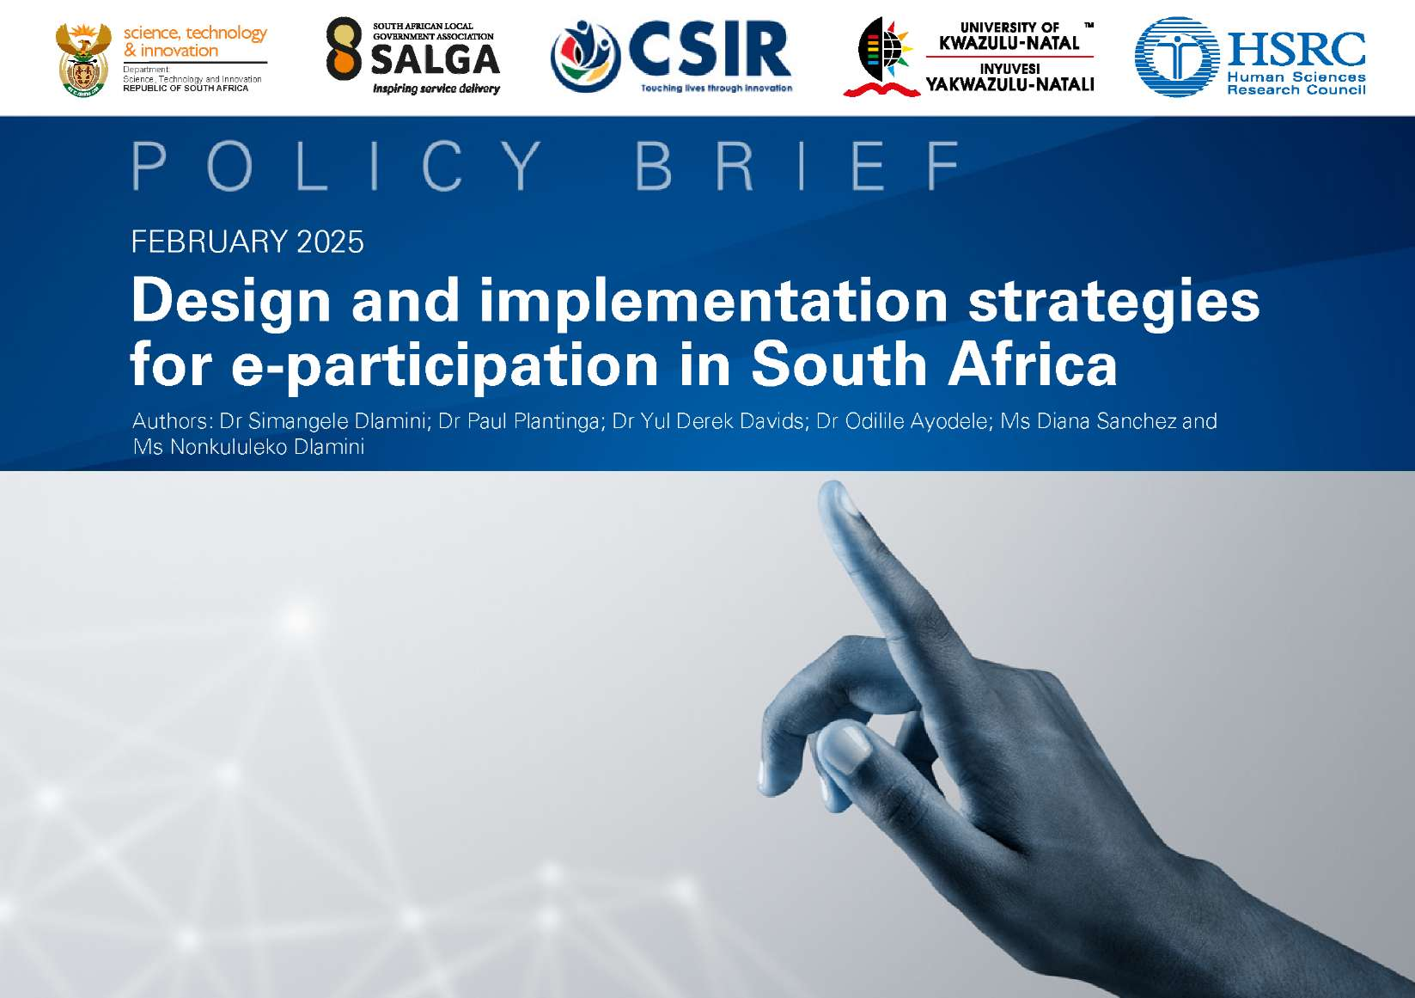

Executive summary
e-Participation in local government enables community voices to be heard, among others, on local economic development, decision-making and enhancing service delivery. This policy brief seeks to answer the question, 'What are the design and implementation strategies that can be used in sustaining digital public participation initiatives at the local government level in South Africa?' In answering this question, we aim to highlight the practical aspects of introducing e-participation mechanisms in local governance structures in municipalities with differing human and material resource capacity levels. This is done through our observations implementing the e-Participation and Policy Modelling Platform for South Africa (ePPMOSA) project, an initiative supported by the Department of Science, Technology and Innovation (DSTI), and implemented by the Human Sciences Research Council (HSRC) with partners. Our findings highlight the importance of stakeholder engagement, technological considerations, and the need for tailored approaches for each municipality's unique circumstances to drive equitable and inclusive citizen participation using emerging technologies at the municipal level. This has policy implications for enhancing e-government and citizen participation in local government.

Action-research approach
This policy brief is based on a review of design and implementation strategies adopted by the ePPMOSA team during action-research activities conducted as part of their collaboration with municipalities to pilot e-participation technologies. This follows an initial investigation of how municipalities use digital technology to enable citizen participation in planning and policy-making processes. The research team was cognisant of the varying social, technical, and economic factors influencing the implementation and use of e-participation tools in the participating municipalities, and this shaped the approach adopted for each of these municipalities.

e-Participation in national and local government
Local governments in a democratic society have a role to play in improving peoples' living conditions and providing real opportunities for citizens to participate in making policy decisions. Adopting e-participation in local governance has emerged as a promising approach to enhance transparency, accountability, and citizen engagement in decision-making processes. In South Africa, this digital transformation aligns with the Batho Pele principles, which place citizens at the centre of public service delivery. These principles emphasise, among others, consultation, transparency, and accountability, and provide a crucial framework for building trust and fostering collaboration between municipalities and citizens in the digital age.
In South Africa, citizen participation is seen as a cornerstone of democratic processes. It is defined as an open, accountable process through which individuals and groups within selected communities can exchange views and influence decisionmaking. When properly implemented and managed, citizen participation can ensure that developmental plans and services are more relevant and responsive to local needs, improve service delivery oversight, and promote community action by empowering communities to take control and responsibility for their lives and livelihoods. This is the essence of participatory governance. Participatory governance speaks to the role of citizens in public administration and policy-making not just as passive recipients, but as active contributors to the decision-making process.² However, while participatory governance is a dynamic and complex process that aims to be inclusive and adaptive, its implementation, including new digital features, is often hindered by entrenched power dynamics and structural limitations. Indeed, as Bernades et al. note: "administrations tend to reproduce in their government portals the same pre-existing governance structure, making decisions in a vertical way (top-down), with reduced transparency and openness to popular participation".³ Overall, as the ability to participate, either digitally or through traditional channels, does not always equate to the ability to make an impact, we need to consider how participatory systems and digital tools are designed and implemented, and how they relate to institutional aspects such as the availability of infrastructure and resources to facilitate implementation.
Studies on e-participation note several common challenges related to citizen participation, including the digital divide (unequal access to digital technologies due to socioeconomic factors), lack of digital literacy (citizens may lack the skills to effectively engage with digital platforms), weak institutional capacity (public institutions may lack the infrastructure or expertise to implement and manage digital governance systems) and concerns about data privacy and security (in many developing countries, weak data protection frameworks can lead to concerns about the misuse of personal data by governments).⁴⁵ Despite these challenges, digital governance has the potential to revolutionise the way citizens participate in governance processes and how governments deliver services. Additionally, much of the literature on practice and policy on e-participation tends to be focused on top-down or government-led activities. There is, therefore, a critical need to consider how public officials can engage with civic-led action, as well as how public entities may relate to conversations taking place in online fora outside their direct control.
It is also important to examine the extent to which technology can help bridge the digital divide and be more inclusive (such as including the elderly and rural communities in decision-making processes). It is crucial to note that the impact of e-participation on policy outcomes depends on several factors, including civic tech education and change management, the attitudes of politicians towards the public, the design of e-participation platforms, the level of engagement and participation by citizens, and the end-to-end management of the whole process.
For the ePPMOSA project team, these considerations are framed by a working e-participation 'stack' outlined in Figure 1 below. The e-participation stack has emerged from the wider literature and through the various meetings and workshops held with municipal officials as part of the project. The idea of a stack - coming from the early days of the Internet⁶ and applied to open governance⁷ - is that by strengthening lower-layer capabilities, it will be easier to implement higher-layer applications and achieve (e-)participation goals. Although this is not a strict rule, it can be a helpful guide. For example, when looking at our e-participation stack, it is difficult to expand the reach and engagement with under-represented or vulnerable residents without having (1) improved data on current or potential participants and their priorities, as well as (2) developing accessible and segmented or relevant content for those audiences. The elements of the stack reflect many of the priorities, opportunities but also concerns identified by officials driving participation activities (mainly), pointing to some 'on-the-ground' realities but not necessarily reflecting what community members see as critical.
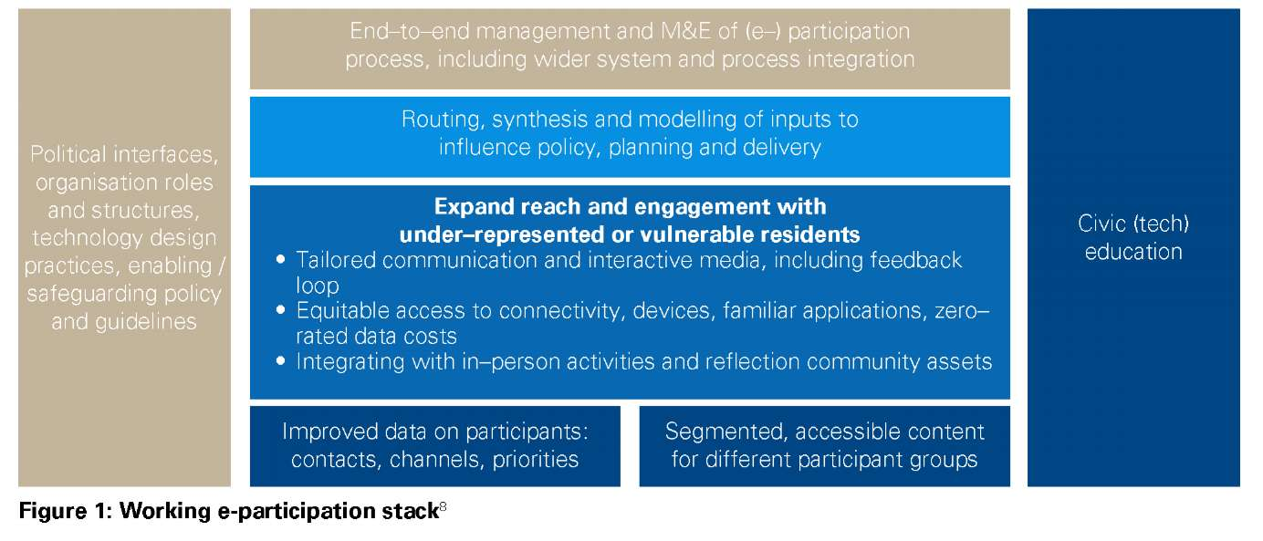
- Shadowne, S., Lodato, T., & Loi, D. (2020). Participatory Governance in Smart Cities. Urban Planning, 5(2), 1-12.
- Bernades, S., Oosteruom, P., & Pfeffer, K. (2018). Participatory Governance and Citizen Empowerment Through E-Participation. In M. P. Rodriguez Bolivar (Ed.), E-Participation in Smart Cities: Technologies and Models of Governance for Citizen Engagement (pp. 173-191). Springer International Publishing: p.453
- Hicks, T. (2023). Community-engaged Interior Design: An Illustrated Guide. Taylor & Francis.
- Hernandez, C. A. (2021). The role of citizens in smart cities and urban infrastructures. In Solving urban infrastructure problems using smart city technologies (pp. 213-234). Elsevier.
- https://www.w3.org/People/Frystyk/thesis/TcpIp.html
- https://saiia.org.za/research/how-civic-technology-can-drive-accountability-in-south-africa/
- Ibid.

ePPMOSA project and municipality pilot approach
The ePPMOSA project has its roots in South Africa's National Development Plan (NDP) and thus primarily aimed at building a capable and developmental state as one of six NDP priorities. From the perspective of the DSTI, the realisation of this priority requires that the public sector, in particular municipalities, adopt innovation and use technology to improve service delivery. The 2019 White Paper on Science, Technology and Innovation (STI) echoes this call and recognises the need for an appreciation of STI in all spheres of government, and the use of STI in municipal planning, delivery and operational processes. As part of a wider Viability and Validation of Innovations for Service Delivery (VVISDP) programme aimed at stimulating innovation in and by municipalities, funded by the European Union (EU) Sector Budget Support Programme and National Treasury, the ePPMOSA project aims to enhance transparency, integrity, accountability and stakeholder participation to support local participatory governance.
The ePPMOSA project team works with municipal administrations and existing public participation structures to support and enhance their engagement with residents and communities by piloting the use of appropriate digital technologies and is mainly focused on influencing municipal planning and policy decision-making. Central to the project is gaining insights from these pilots to inform future design and implementation, developing recommendations and guidelines, and ensuring that knowledge and experiences are shared within a network of practitioners.

Key lessons for e-participation project design and implementation in municipalities
- Front-line innovation to meet immediate needs
The initial approach to implementation envisioned developing a national technology platform for multiple municipalities. However, early engagements revealed that each municipality's needs and technology use would differ significantly due to varying capabilities and priorities. A common concern from officials was around the use of advanced technology platforms, for which they feel there is insufficient in-house skills to operate and that tend to have high costs. This led to reorientating the project towards supporting a more diverse mix of municipality-driven approaches, emphasising leveraging available resources and capacities that could be sustainable in the longer term.
- Local peer-learning as a priority
Closely connected to the above dynamic of user-driven innovation, is a strong push from partner municipalities' to have more peer exchanges with other users at local municipalities. Officials involved in public participation emphasise that experiences and lessons from other municipalities are invaluable for guiding their e-participation initiatives. This led to a reworking of the project resources to better support peer-learning interactions, especially through an annual group workshop but also through targeted bilateral exchanges. Peer-learning extended beyond municipality interactions to include exchanges with local governments in other regions, such as the Bogota entity supporting public participation; similar projects, such as the COMPACT public participation initiative; and with more grassroots (South) African e-participation innovators, such as through hackathons and the annual Civic Technology Innovation Forum (CTIF).
Through these engagements, and the CTIF in particular, it became clear that existing innovations, resources and networks on the African continent can be an important source of learning and partnering for the piloting and implementation of e-participation by municipalities.
- Research council as action-research intermediary
From the above activities, it is evident that the ePPMOSA project team is playing the role of e-participation design and implementation intermediary, linking different officials and external actors to various activities. To a large extent, this role was explicit in how the original project scope was developed, but there has been some evolution in what this mediation role involves. One of the most significant shifts has been a change in the project team's orientation; away from gathering and consolidating municipality public participation challenges and 'requirements' to build a 'platform', towards facilitating municipal officials' identification of existing internal capabilities and available or appropriate technologies that could be adapted and incorporated into their practices.
- Political influences on e-participation
As initial engagements between ePPMOSA researchers and municipal officials progressed, there was a stronger recognition of how this project - within the wider set of VVISDP projects - is especially sensitive to and affected by informal and formal political interests. This is due to the potential impact that digital participation and (re-)intermediation can have on communication flows between the municipality officials, councillors, residents and other actors such as political party branches, ward committees, community organisations, and traditional leaders amongst others. Whilst municipalities applied to join the project, through a Speaker or Municipal Manager Office, which suggests that there would be demand for technology use, the reality is that the applying person or unit would often still need to enrol support from other relevant departments in the municipality, as well as from formal political stakeholders in the form of Councillors and via Council. Councillors are often central to how information flows between municipalities and communities and so a key consideration for ePPMOSA is how new technology implementations may (or may not) be integrated with and supported by Councillor communication channels.

5. A system perspective
Whilst the original objective and activities of the ePPMOSA project had a strong national, 'platform' orientation, during project implementation, there has been a strong pull towards a more decentralised and co-creative implementation approach. This has been supported by DSTI and may reflect a wider interest in the country around mission-oriented and transformative innovation policy approaches. Under these innovation paradigms, the ultimate goal is transformative change in practices and outcomes at national or global level, but this is achieved by encouraging decentralised experimentation that is directed and protected or nurtured by a wider, national system frame. At an organisational level there is also an awareness that these e-participation initiatives would need to link with other systems, and that implementation should align with responsible IT and data governance practices. The current approach it to emphasise open interfaces and standards (and being able to export data), whilst routing higher risk interactions (like collecting personal information) to existing systems.

Implications for policy and practice
The intention of the ePPMOSA project is to support e-participation pilot projects and provide insights into their benefits and implementation challenges in different contexts. The wider outcome of such support is an informed e-participation community, and active, diverse, multi-stakeholder networks that support knowledge exchange on e-participation (and its links to policy modelling).
- Learning and designing-by-doing: It is crucial to involve municipal officials and stakeholders (ideally community- based users) in designing and implementing e-participation technologies, and doing it in a way that allows for hands- on learning.
- Establishing a learning knowledge system: Peer-learning was noted as critical for enabling the adoption of technology-related practices, and forms part of a system of innovation interactions. The role of research intermediaries in the system can vary, from sourcing information, to facilitating exchanges or directly supporting implementation. Recognising how dispersed activities contribute to changes in, and are nurtured within, a wider system of policy, rules and norms is important.
- Transparent political interfaces: The prevalence of political actors and politically-supported channels in South Africa's (e-)participation suggests that a more explicit understanding is needed of its role. Digital technology design should, at least, recognise the need to enhance transparency and public understanding of political-administrative interfaces and roles, and enhance the provenance of decision-making and consistency of information availability so that publics can trace planning and service delivery through political fluctuations.
- Accountability, inclusiveness and responsiveness in policy and planning: Ultimately, it is anticipated that initiatives like ePPMOSA will have policy impacts at the municipal level around strategic planning and foresight, results-based management and performance management, among others. They may also lead to accountability by supporting proactive disclosure of information, open governance, and transparency. Additionally, technology can support inclusiveness; in the formulation of the Integrated Development Plan (IDP), in participatory budgeting, and in long-term planning and spatial development. It's use can result in better-informed officials, empowered communities, and improved responsiveness in the municipal governance process.

Acknowledgements
We acknowledge the DSTI, who, in partnership with the South African Local Government Association (SALGA) and the Department of Cooperative Governance and Traditional Affairs (CoGTA), together with the European Union Sector Budget Support Programme and the National Treasury, funded this project. We also want to acknowledge the participating municipalities in the ePPMOSA projec. This project has been granted research ethics clearance by the HSRC Research Ethics Committee.

The HSRC is partnering with the Council for Scientific and Industrial Research (CSIR) and the University of KwaZulu-Natal (UKZN) in the project.
https://www.nationalplanningcommission.org.za/National Development Plan
https://www.dst.gov.za/index.php/legal-statutory/white-papers/2775-white-paper-on-science-technology-and-innovation
https://www.dst.gov.za/images/2021/02/Innovations-for-Service-Delivery-Programme-Call-for-expressions-of-interest-from-municipalities.pdf
With reference to the e-participation spectrum, see: https://publicadministration.un.org/en/Research/UN-e-Government-Surveys
https://www.participacionbogota.gov.co/
https://pari.org.za/compact/
https://www.capetown.gov.za/Media-and-news/City%E2%80%99s%20Inaugural%20Innovation%20Hackathon%20paves%20the%20way%20for%20enhanced%20public%20 participation%20platforms
https://civictech.africa/ctif/africaflows-conference/
https://www.dst.gov.za/images/2021/Annexure 5 - Innovation Project 5 - eParticipation and policy modelling platform for municipalities.pdf
https://www.sanews.gov.za/south-africa/dpsa-minister-calls-mission-oriented-approach-public-service-innovation
https://www.uj.ac.za/faculties/college-of-business-and-economics/trilateral-research-chair-in-transformative-innovation/transformative-innovation-policy-south-africa-tip-sa/

