



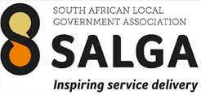


e-Participation in Municipalities and Youth Engagement
10 April 2025

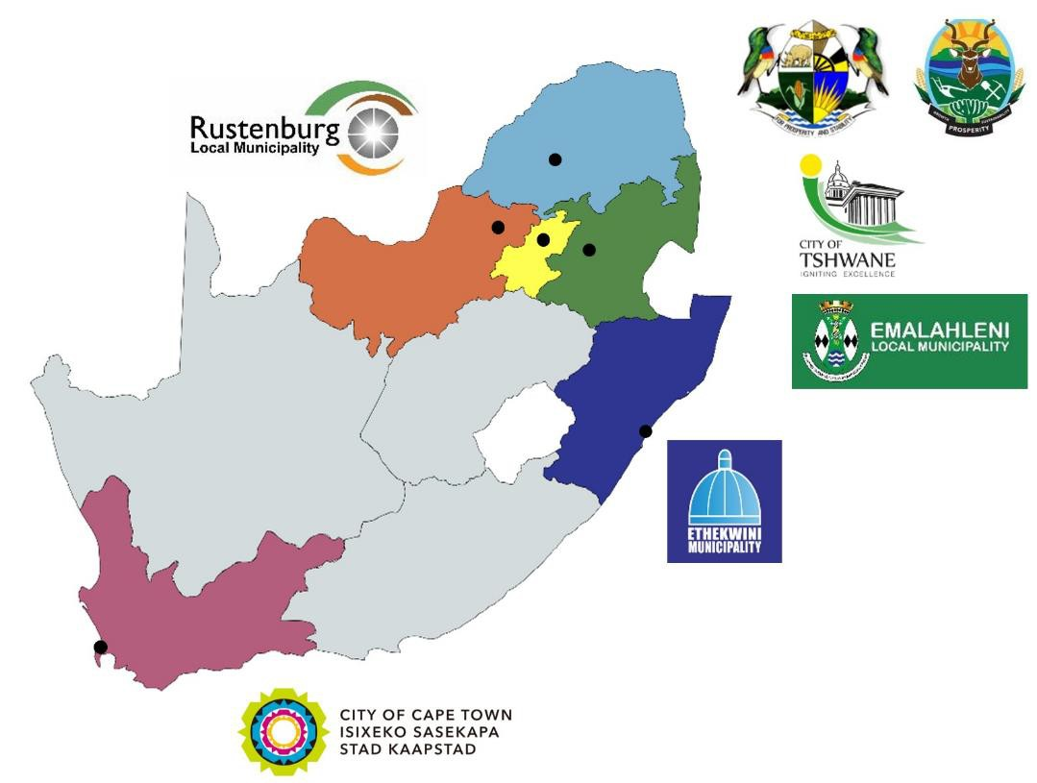

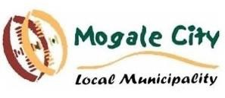
‘e-Participation’ pilot projects in municipalities

- Viability and Validation of Innovations for Service Delivery Programme (VVISDP): EU-funded, managed by Department of Science, Technology & Innovation (DSTI)
- Project 5 of VVISDP: e-Participation and Policy Modelling Platform for South Africa (ePPMOSA)
- Aims to:
  - Understanding how municipalities want to enhance public participation
  - Test use of tech in +-6 pilot projects
  - Support peer-learning amongst municipality practitioners and researchers

e-Participation in policy/ planning as focus

Less engagement
Construction of political discourse | Policy-making | Public service delivery
Political parties’ website, social  media | Provision of information on laws, regulations, strategies, budgets, administrative processes, etc. | Information on public services,  open government data
Voting advice applications, parties platforms, candidates’ website, social media | Ideation forums, parliamentary inquiries, consultations on draft policies | Customer feedback, consultations on services, participatory planning (e.g. urban)
E-voting and m-voting | E-voting and m-voting (e.g. for  budgeting, referendum) | Co-production (e.g.  crowdsourced disaster maps)
Agenda setting (e.g. e-parties,  collaborative electoral platforms) | Citizens’ initiatives, e-petitions | Co-creation (e.g. innovation  competitions, hackathons)

Provision of
information

Consultation

Collaboration
More political Less political

Empowerment

More engagement

Participatory budgeting
UN DESA (United Nations Department of Economic and Social Affairs). (2020). UN e-Government Survey 2020. https://publicadministration.un.org/en/Research/UN-e-Government-Surveys

Drawing on diverse expertise
Government experience and expertise with (e-) participation and policy formulation




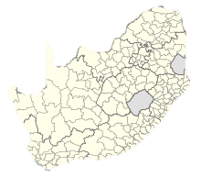



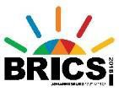

South African civil society and civic tech networks, platforms and capabilities
International projects,
technologies and
methodologies

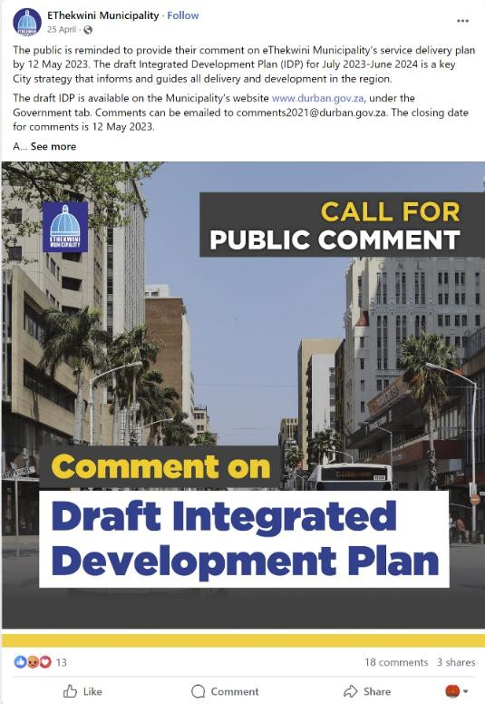
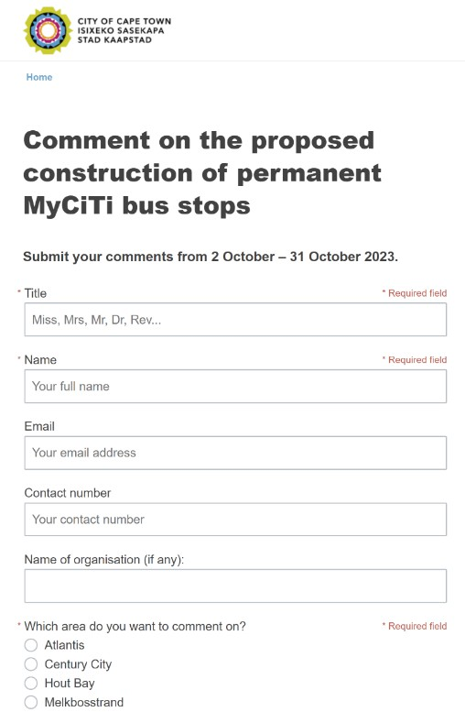
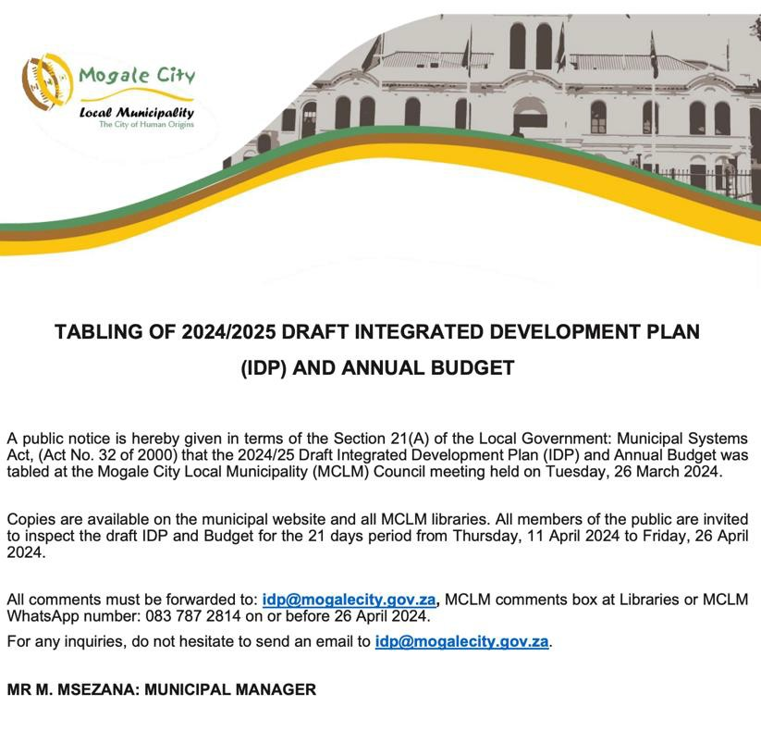
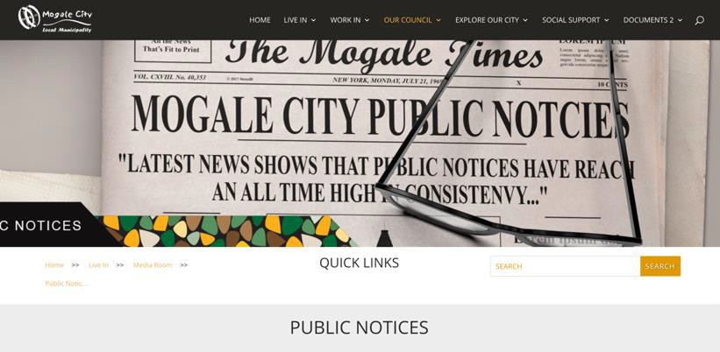
e-Participation in policy/ planning? ... Currently

https://mogalecity.gov.za/wp-content/uploads/Pdfs/Media%20Room/Public%20Notice/2024/Publ ic%20notice%20-%20IDP%20Apr%202024%20.pdf?_t=1712743194
https://www.capetown.gov.za/City-Connect /Have-your-say/Issues-open-for-public-comment/pr oposed-construction-of-permanent-myciti-bus-stops
https://www.facebook.com/profile/100064731846736/search/?q=IDP

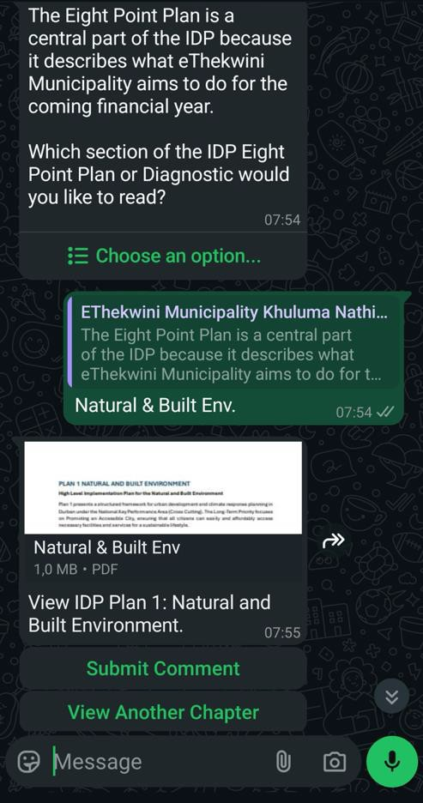
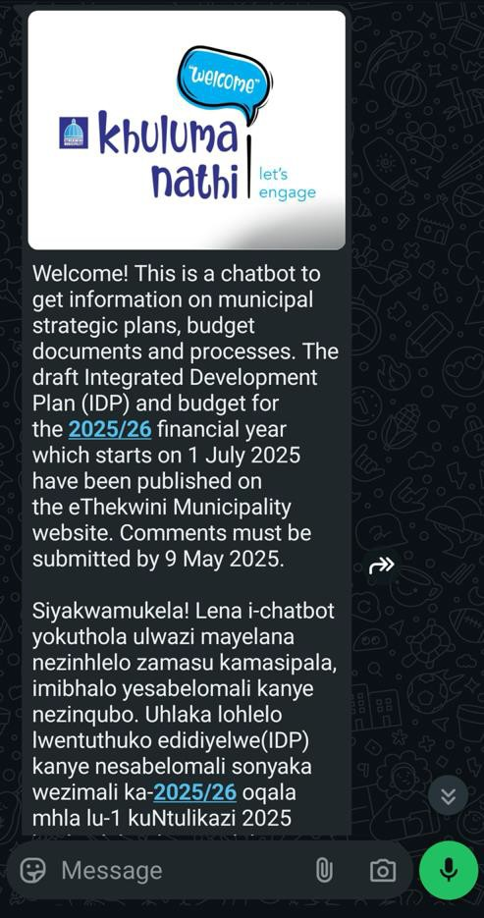

e-Participation in policy/ planning? … Pilots

Website/ app | Lower cost, more  accessible, mobile-first
Large docs | Focusing on relevant content (ward priorities & capex for now)
Static text | Interactive maps and data infographics
One-way, opaque | Transparent, collaborative  ➔ workshop enablers
English docs & written submissions | More languages, other ways of making input

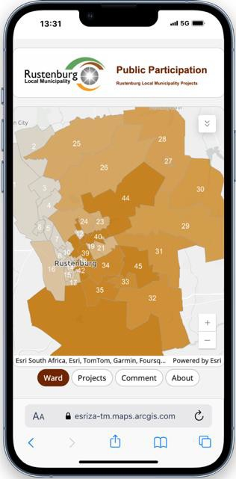
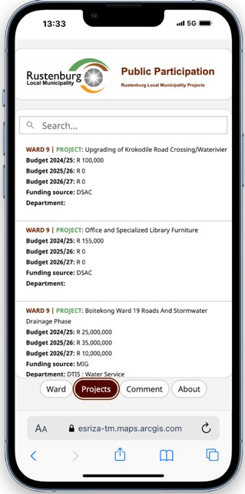
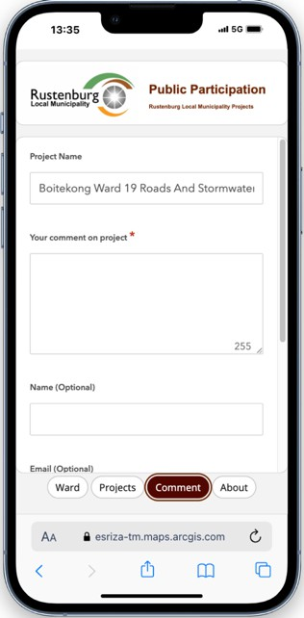
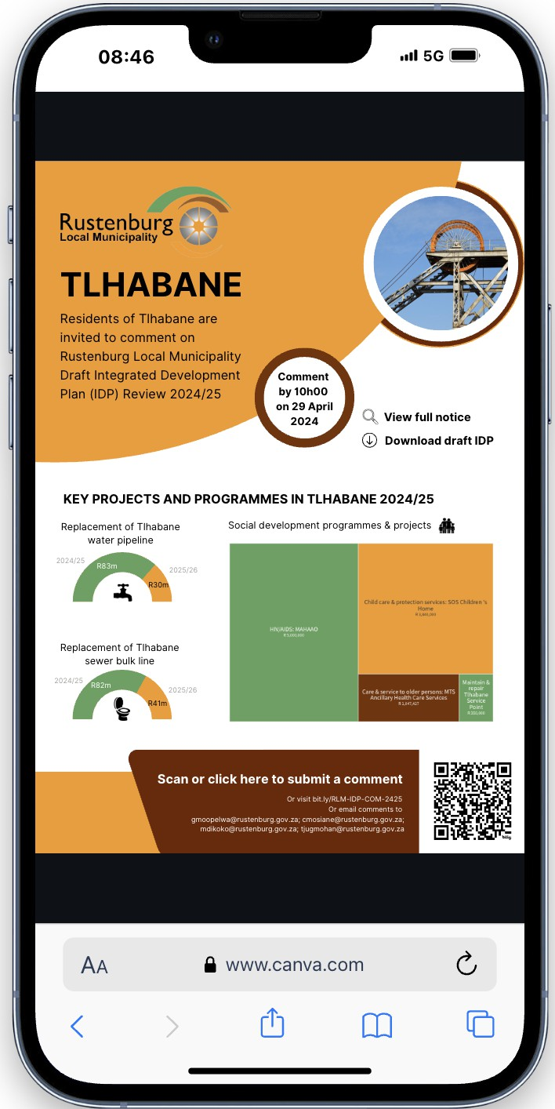
e-Participation in policy/ planning? … Pilots

Website/ app | Lower cost, more  accessible, mobile-first
Large docs | Focusing on relevant content (ward priorities & capex for now)
Static text | Interactive maps and data infographics
One-way, opaque | Transparent, collaborative  ➔ workshop enablers
English docs & written submissions | More languages, other ways of making input

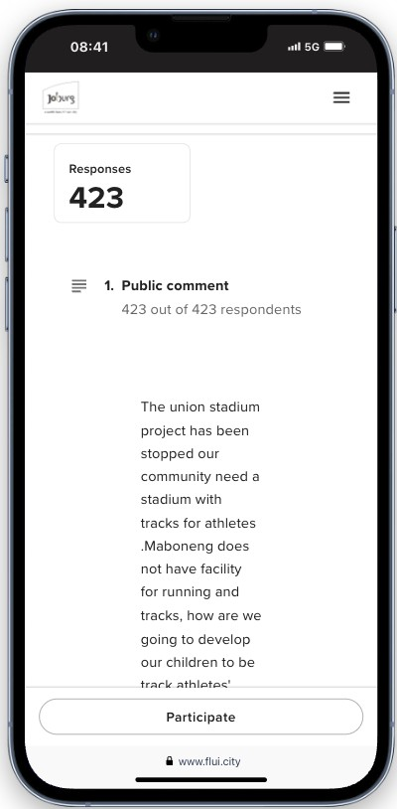
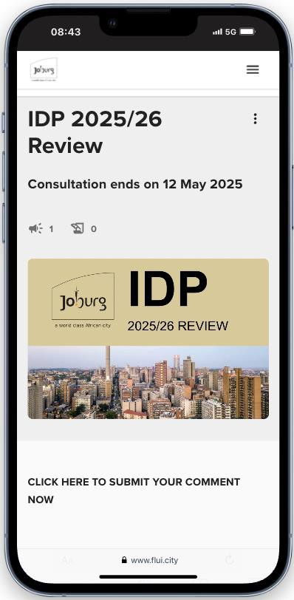
e-Participation in policy/ planning? … Pilots

Website/ app | Lower cost, more  accessible, mobile-first
Large docs | Focusing on relevant content (ward priorities & capex for now)
Static text | Interactive maps and data infographics
One-way, opaque | Transparent, collaborative  ➔ workshop enablers
English docs & written submissions | More languages, other ways of making input

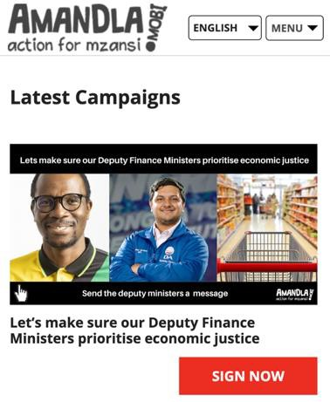
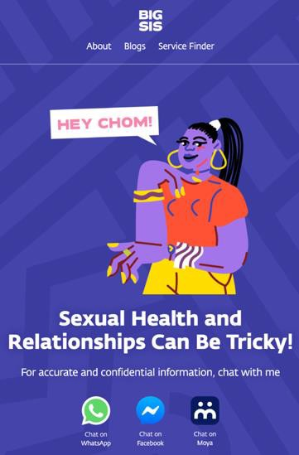
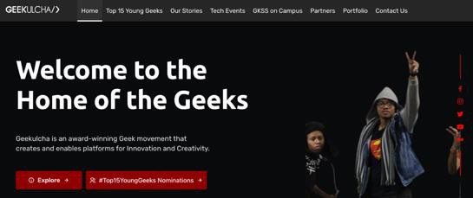

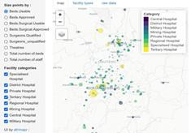

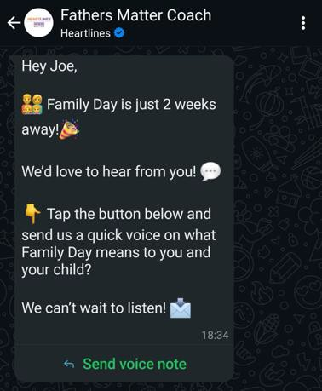
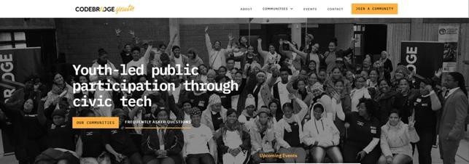
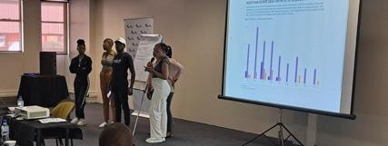
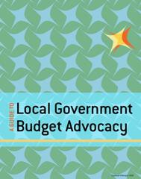
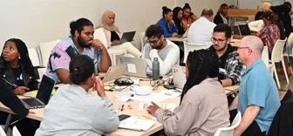
Vs. Civic and youth-centric tech

Top-down: informing,  consulting | Bottom-up: petitions/ campaigns
Strict interaction boundaries | Open, social
Formal | Friendly, colloquial
Regular sector or regional plans | Current, audience & issue-focused
Traditional channels, formats | Multi-media, data storytelling
Tech build & deliver | Tech ecosystem, skills development, community, diversity, multi-role

Vs. Civic and youth-centric tech
What can we draw on for municipality engagement?
Top-down: informing,  consulting | Bottom-up: petitions/ campaigns
Strict interaction boundaries | Open, social
Formal | Friendly, colloquial
Regular sector or regional plans | Current, audience & issue-focused
Traditional channels, formats | Multi-media, data storytelling
Tech build & deliver | Tech ecosystem, skills development, community, diversity, multi-role

Open, social and multi-channel:
  - Explore use of tech
  - Work on audience, content, language, media
  - Address safety ➔ moderation (tech, skills,
guidelines)
  - Interface with bottom-up engagement (?), more continuous conversation flow

Ecosystem view:
  - External roles (intermediaries): community journalists, junior council, SRCs, civic devs
  - Internal roles: designers, aspiring data scientists, public participation officers
  - Include in upstream tech design and dev

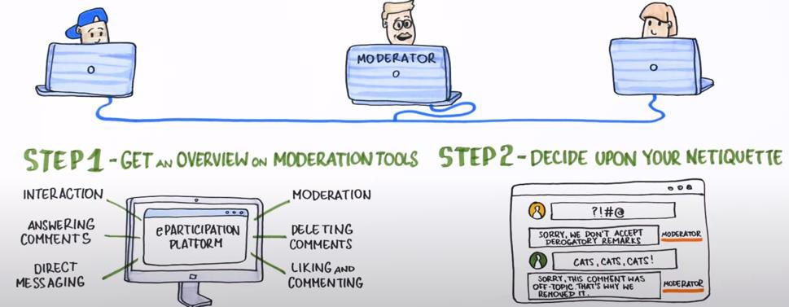
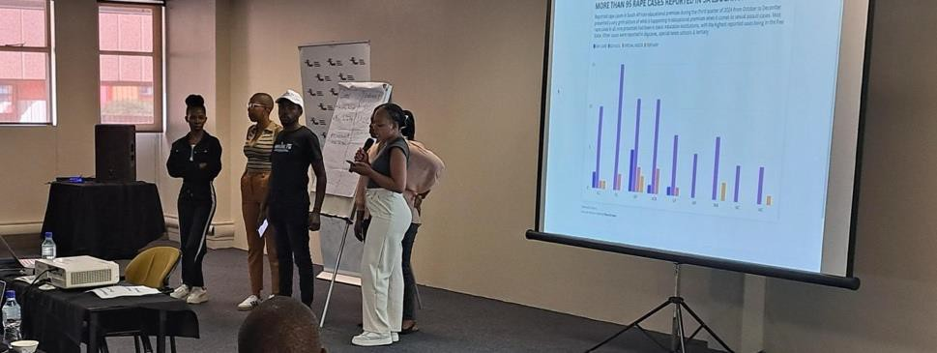
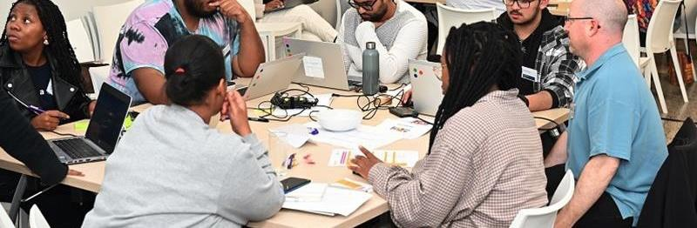
Vs. Civic and youth-centric tech

Top-down: informing,  consulting | Bottom-up: petitions/ campaigns
Strict interaction boundaries | Open, social
Formal | Friendly, colloquial
Regular sector or regional plans | Current, audience & issue-focused
Traditional channels, formats | Multi-media, data storytelling
Tech build & deliver | Tech ecosystem, skills development, community, diversity, multi-role

Thank you



